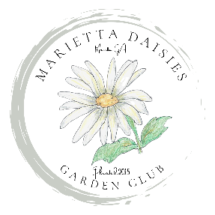
Marietta Daisies Garden Club
C/O , Mary Ellen Leffard, Treasurer
1040 Ector Chase NW
Kennesaw, GA 30152
Maryellen.leffard@gmail.com

REQUEST FOR REIMBURSEMENT

Date: _____________

Name: _______________________________________
Address: _____________________________________
City, State, Zipcode: ____________________________
Phone: _______________________________________

Expenses:
Date Detail of Expenses Fund/Acct to be Charged Amount
_______ ________________ _____________________ _______
_______ ________________ _____________________ _______
_______ ________________ _____________________ _______
_______ ________________ _____________________ _______
Total: _______

Make Check Payable to: ____________________________________
Mail to (if different from above): _____________________________
_____________________________
_____________________________

Authorization: (name/position): ______________________________
(date)
President’s Approval: ________________________________________
(date)
Please attach receipts and submit to above address within 30 days for reimbursement.

Paid Check #________ Amount $_____________ Date___________

